BAJO MICHAEL

ALBERTO’S CLOCK AND WATCH SHOP DOCUMENTATION

TABLE OF CONTENT

* ACKNOWLEDGEMENT
* SYNOPSIS
* PROBLEM STATEMENT
* SCOPE OF THE PROJECT
* ARCHITECTURE AND DESIGN OF THE WEBSITE
* SCREENSHOTS
* USER GUIDE

ACKNOWLEDGEMENT

We would like to appreciate the Lord, God Almighty for seeing us through the process of executing this project. He has always been extremely faithful.

Our Sincere gratitude also goes to the entirety of Aptech Computer Education, Abeokuta-right from the faculty to our colleagues for their timely professional advice and support.

We appreciate the efforts of everyone that contributed to the success of this project. God bless you all!

SYNOPSIS

Alberto’s Clocks and Watch Shop is a store that provides an easy shopping facility and repair of clocks and watches of all types and at affordable prices for the customers, wherein they can sit at one place and shop online anytime, anywhere 24/7.

**Alberto’s Clocks and Watch Shop** website has the following features:

* Basic information about the products we have.
* Product section for viewing different services that has been listed.
* Contact platform and links to social media.
* Implementation of Google maps for easy location of store.

PROBLEM STATEMENT

**Alberto’s Clocks and Watch Shop** is a full-service watch repair, appraisal, and retail store – offering the finest selection of luxury timepieces. Offering an unparalleled selection with first-class service.

Alberto also carries a wide selection of brand new watches such as Michael Kors, Rolex, Citizen Eco-Drive, Bulova and more!

You are supposed to create a Single-Page-Application and responsive Website for them with the below mentioned requirement specifications.

The website is to be developed for the Windows Platform using HTML5, JSON, Angular JS, JavaScript and Geolocation. The site should work well in all leading browsers including Chrome, IE, Firefox etc.

SCOPE OF THE PROJECT

1. This site displays a menu with the following categories:

* **The Home Section**
* **Products**
* **About Us**
* **Contact Us**

1. Products section contains all the products available in a gallery format.
2. There is a Contact Us section which has the address of the shop which is as follows and the mail address which when clicked will invoke the local mail client from where they can send an email. The address of the store is displayed using Geolocation API (e.g. Google maps).

ARCHITECTURE AND DESIGN OF THE WEBSITE

Alberto’s Clock and Watch Shop like every other website on the internet has a client-server architecture. This implies that this project is hosted on a server from which the clients (users in this case) would get access to the website.

SCREENSHOTS

Nobody needs to be taught how to use the internet but sometimes, it is necessary to familiarize ourselves with certain environments. Two sites may have the same aims and objectives but they would surely have different modes of implementation. This is why we have decided to point out some important aspects of **Alberto’s Clock and Watch Shop** website using visuals.

* Navigation menu.

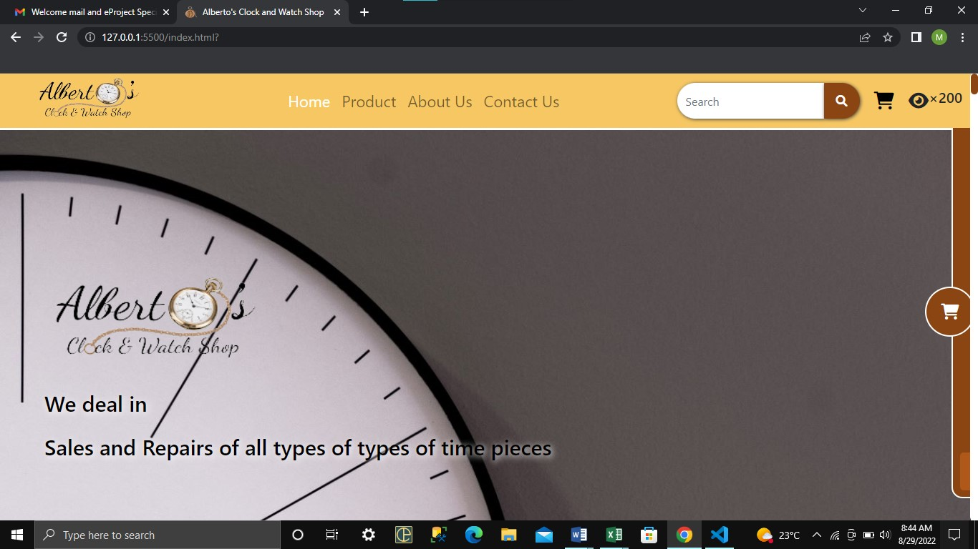

This displays a navigation located at the top of the page.

* Some part of the product section

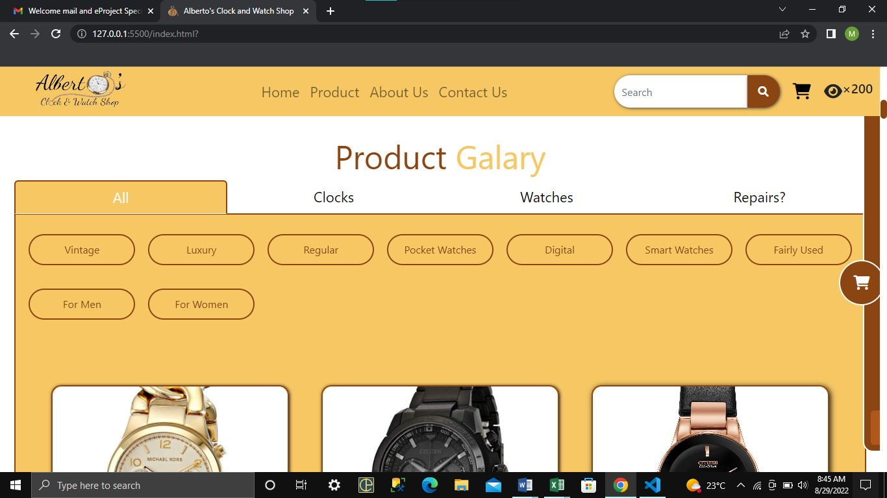

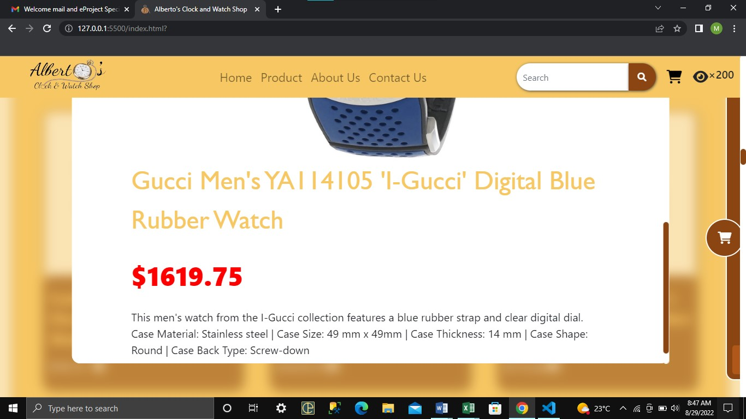

The product section is divided into sections

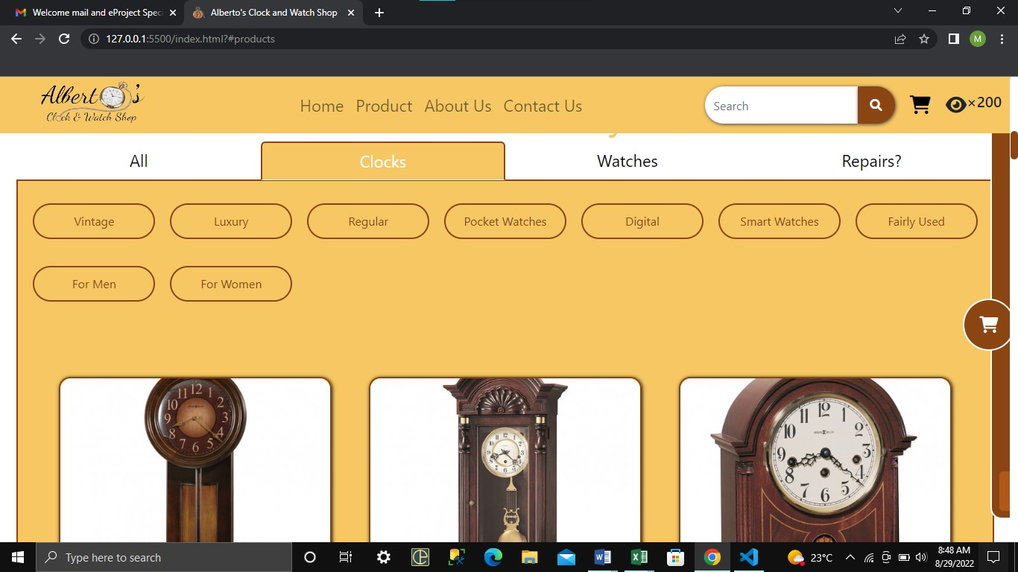

* Google Map

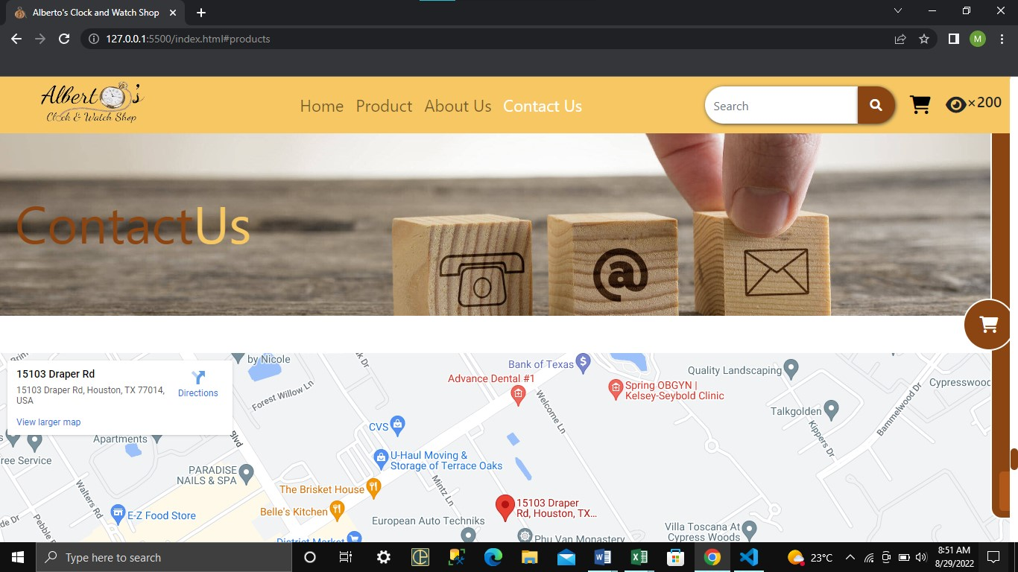

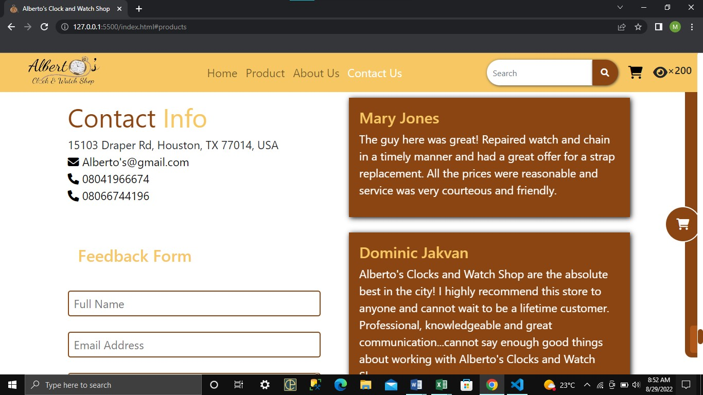

What if there is need to contact people in charge? There’s absolutely no problem with that as Google maps has been integrated into the website to ease that process.

* User-friendly Screenshot.

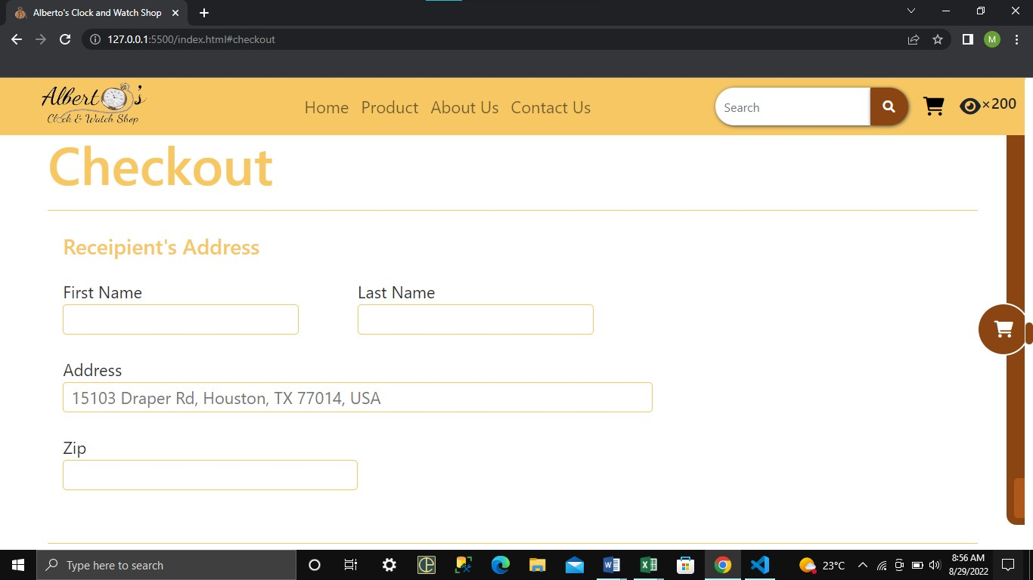

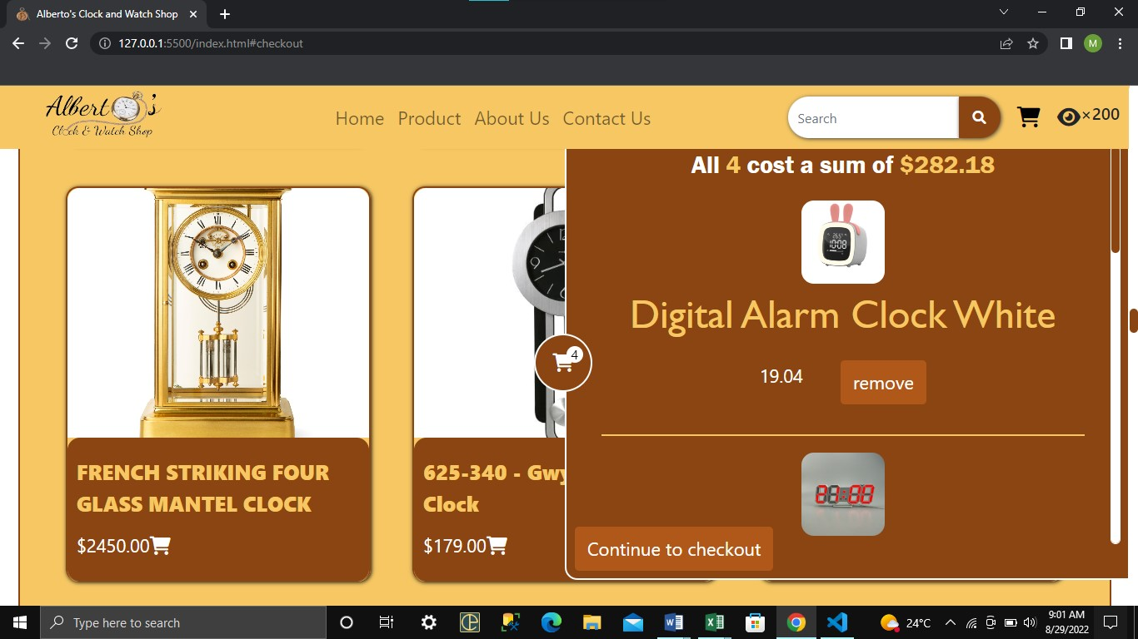

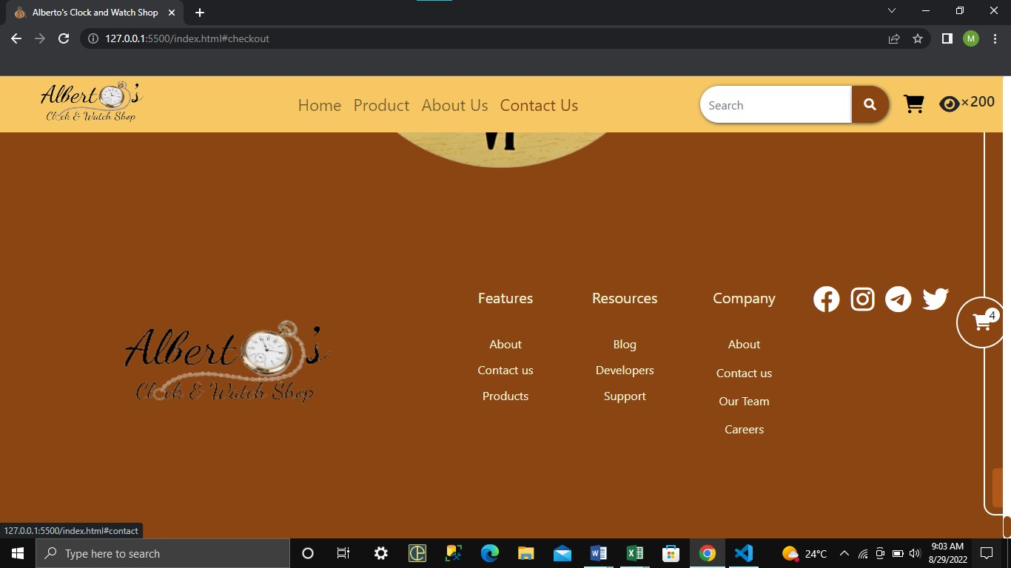

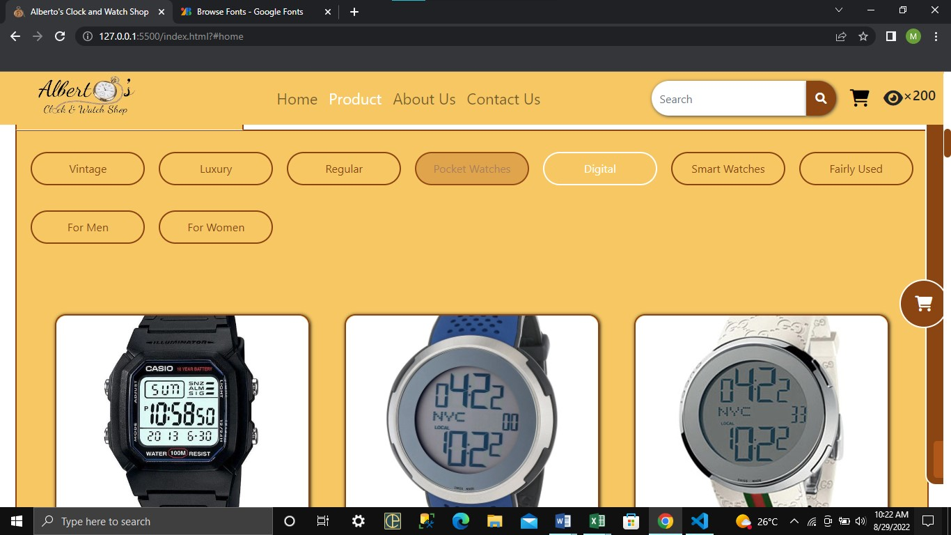

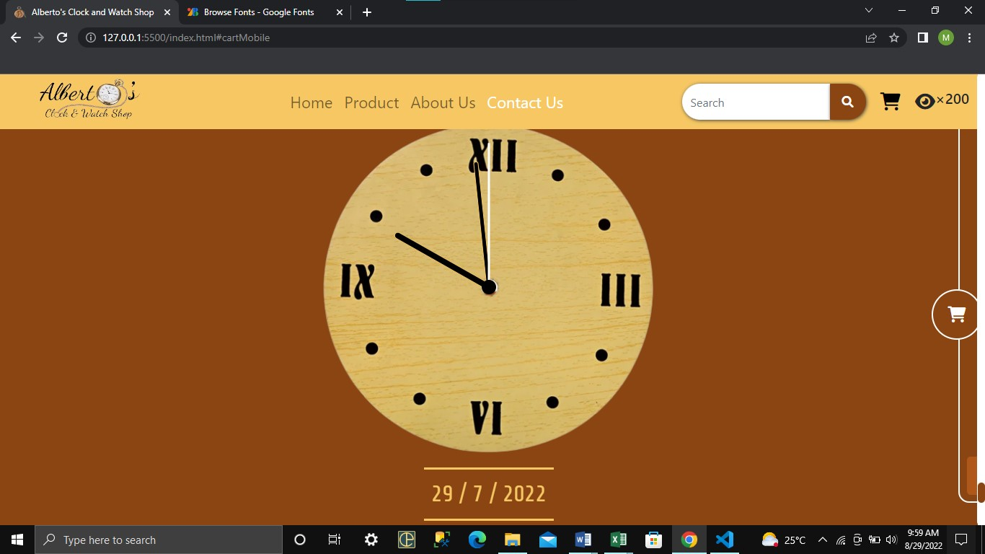

All attractive webpage has been added to the website to showing all the fun.

USER GUIDE

SYSTEM REQUIREMENTS

* Operating system: Windows 7 or higher OS.
* Get the Website running.
* Host the website on a server.
* Access the website by typing in the domain name in any HTML5 and JavaScript supporting browser.
* Navigate the website using the user-friendly navigation menu and links.

Software:

* Notepad/HTML editor, Dreamweaver IE 5.0/Netscape 6.0.

Hardware:

* A minimum computer system that will help you access all the tools in the courses is a Pentium 166 or better.
* 64 Megabytes of RAM or better.